Dean Hickman
CS 152 A
Prof. Allen Harper
18 Oct 2022
Project 04: Penguin Population Viability Analysis

Abstract
The purpose of this project was to build on the development and implementation of functions and garner a deeper understanding of “main functions” as it relates to population modeling. Our key focus however was randomization. We had a set of parameters that held random variables, so each time a portion of the code was run, let’s say a plot function for extinction, a different result would be generated each time. We imported a package called random and what that is, is like ordering a battery for your car. It is something useful and necessary for the car to function, but it has its internal mechanisms. The random package has its own code that makes it work, but we can just import it for use to make our code work. The program penguin.py takes in a set of parameters like population size, the standard growth rate of the population, the carrying capacity of the ecosystem, etc. It then runs the main function with the argument sys.argv to model the extinction probability for any number of simulations and years between an El Nino event. The nitty-gritty details are explained through comments in the code, but all one needs to know about this project is that through randomization and user input in the command line one can model the extinction probability of penguins in the Galapagos Islands with visual graph plots.
Methods
The instructions for task completion were very clear-cut and almost like a step-by-step guide. We used a modular hierarchal design to build this program. This means simply that we wrote functions line by line, tested them, debugged them then moved on. This method is generally preferable because it allows programmers to not be deterred by code that does not run properly. We don’t have to sift through 400 lines of code to find that one syntax error. I was able to read the task instructions and conceptualize what I was being asked to do and write a function line by line and then test it.
I will say my approach didn’t change much from the previous projects, I am still a firm believer in having rough code and translating that into precise python language. I can still debug the code line by line this way and not have concerns about debugging the entire code.
Results
The results of this code are data in the form of visual graph plots that will be inserted into this section as figures. We can have the user running the program type into the command line three arguments: 1.) the program name, 2.) the number of simulations to run, and 3.) the years between an El Nino event. Once a user types this into the command line the main function will run, it takes the argument sys.argv to do so. Sys.argv is fulfilled with the three inputs, it will run to those inputs and display a graph of CEPD vs. Years. The cumulative extinction probability distribution (CEPD) is a list of the number of simulations where the population goes extinct divided by the total number of simulations run. To get this distribution, we had to make a function to compute it and put the data in a list. This output would be the Y-axis of the figures seen below.
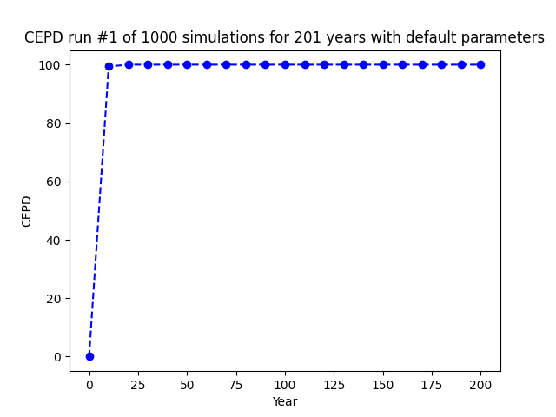
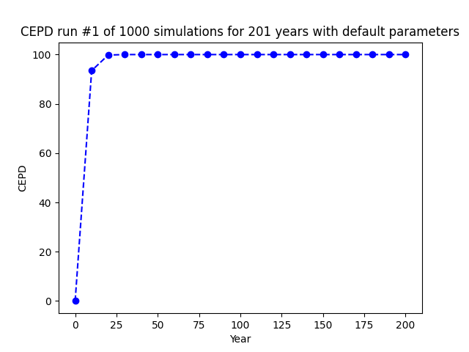
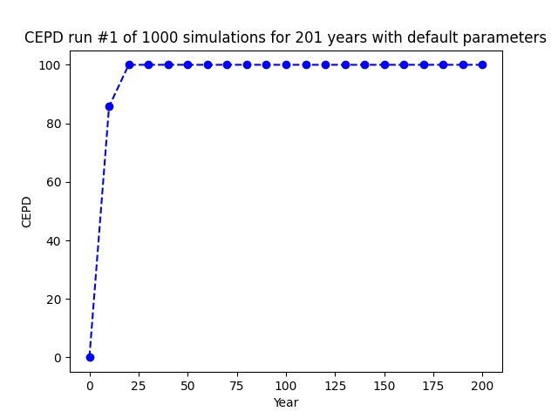
The plots each show that the as the years between El Nino events increase the penguin population is less likely to go extinct sooner. Take figure 2 for example, with 5 years between each El Nino event there is about a 95% probability that the penguin population will go extinct within 25 years for figure 3 at 7 years that probability decreases to 85%. This would make sense because the El Nino year hinders the growth of the population so the less frequently it occurs the better it is for the population. CEPD vs Year plot will show that the population is likely to be extinct at the occurrence of an El Nino year (see plots below), so if there is regularity in the occurrence of an El Nino Year the population will not have time to recover, and be viable, it will die out.
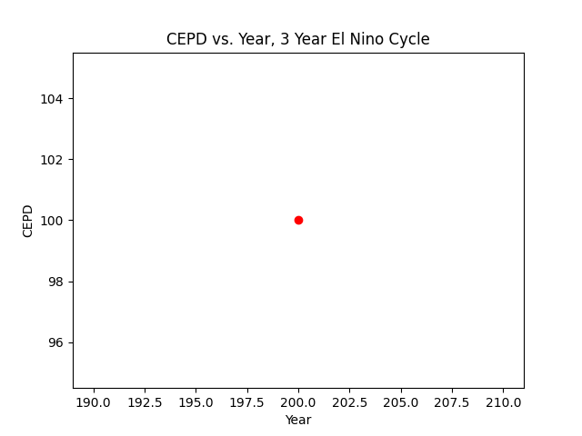
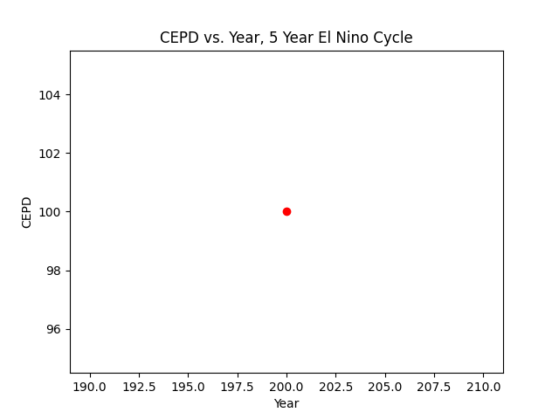
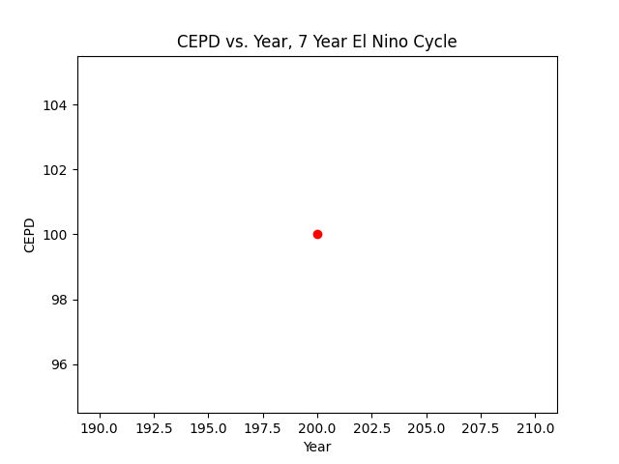

Discussion
- The difference in the codes is that example 1 iterate through the length of the list and prints the value of the item for its index. Example 2 will print each value in the list. The outputs are the same.
- We test code incrementally so that debugging is easier and more manageable. If we don’t do this finding the error in the code is more difficult and you won’t know how many errors, you have.
- The choice for random numbers in this population model was so that we could model the uncertainty and irregularity of the real world. It is easy to make predictions with predictable items, but what predictions can you make without that certainty of knowing what’s next?
- My favorite undomesticated animal is a horse.
The penguin.py program offers a real-world application of modeling population viability given environmental concerns. In calculus, we can use differential equations and optimization equations to do similar things but the difference here is that we can vary more than one input and simulate it more than once. The bulk of this code is modulated, meaning that there are functions strung together to make up one larger function, the main function. What is cool about this program is that it takes the data and formulates it for you in a visual representation, if we equate this to doing it by hand, we would be looking at papers of equations and not a screen of 400 lines of code. Simply put the penguin.py program takes what could have been a bunch of messy equations and complex data and formulates it into something more readable. In the real world, you want to be able to harness the complex, talk about it, conceptualize it, and explain it. Penguin.py is the epitome of the genius coding can do.

Extensions
No extensions were completed for this project.

References/ Acknowledgments
The collaborative environment of computer science has always been a magnet for me; therefore, I love it. I was fortunate to be able to work with the army of elephants for this project, I struggled with generating my plots and getting the command line arguments to function properly. Tricia Yang, Yelaman Moldagali, Allen Harper, and Will Goodman, all helped me with varying aspects of those problems. The toughest one was being able to get matplotlib as a plot, which Professor Harper helped me with. I was able to complete the bulk of the project independently but being able to collaborate and see what other people had in their code gave me new ideas and adjustments that I could potentially have put into my code. Additionally, this code imported three packages, all of which are fundamental to the program running successfully. They are the random package, matplotlib as plt, and the sys package.

